Are you ready to lose weight permanently?
Join Target Fitness!
A professional nutrition therapy program!
This online 10-week comprehensive and innovation nutrition education, wellness and lifestyle program is led by Registered Dietitians who will empower you to reach your target weight!
Programs are starting April 1st, 2021!
Please register using link below or send an email to nutrition@stonybrookmedicine.edu.
Zoom links will be sent out to participants.

Our team of nutrition experts provide you with:
- A sustainable, customized nutrition program you can follow for life
- A body composition analysis (measure of body fat and muscle)
- Intensive education on research-based strategies for permanent weight loss
- Personalized short and long-term weight goals
- Stress reduction, mindful eating & behavior change methods
- Training on innovative tools that will change your relationship with food
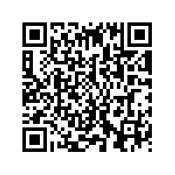
- Guidelines on reading food labels and a supermarket tour!

Get off the weight loss roller coaster!
Join Target Fitness Today
Enroll today by completing intake form:
- Scan QR code OR
- Go to: https://stonybrookuniversity.co1.qualtrics.com/jfe/form/SV_8ivn1FDY8ZEeEUB

$190 per person for the 10-week program payable before start of classes. Payments are non-refundable and non-transferable.

