


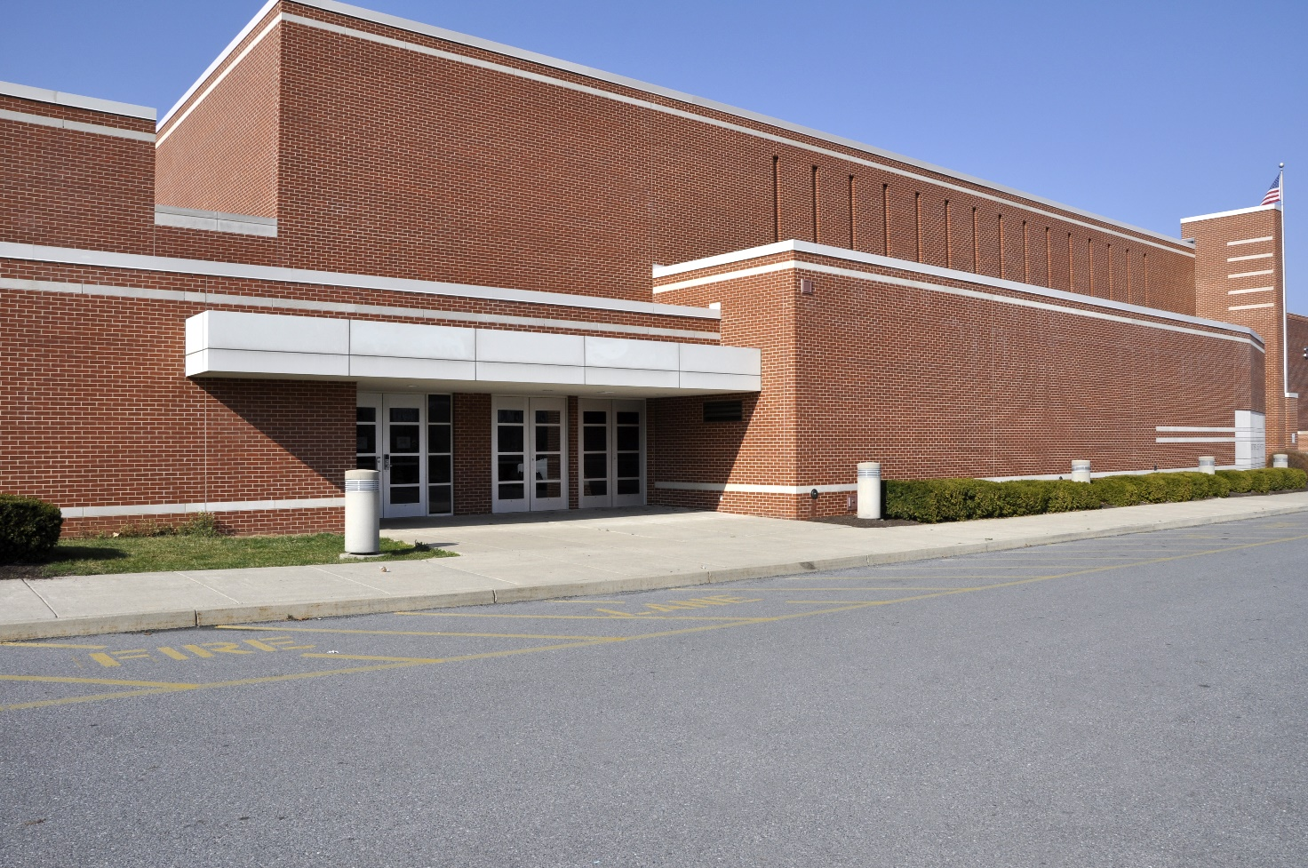

Image copyright Cynthia Farmer, used under license from Shutterstock.com.

.
Shougnouse High School
Active Shooter
Tabletop Exercise (TTX)

  - Situation Manual
  - Monday, August 15, 2022

Welcome and thank you for participating in today’s tabletop exercise. This document, referred to as a Situation Manual (SitMan), provides exercise participants with all the necessary tools to fulfill their roles in the exercise. You will only need to bring with you your knowledge and understanding of your agency’s emergency policies and protocols.

Included in the SitMan you will find basic information about what to expect during the exercise, other participant organizations and further instructions about your participation. You will also see some of the exercise planning elements (e.g. objectives for the exercise), as well as a scenario narrative. Updates to that scenario (injects) and discussion questions that will facilitate a conversation about agency specific/interagency plans and response activities will be provided as the exercise progresses. Throughout the exercise, we will be documenting the dialogue for the purpose of improving the overall knowledge base of the participants which will facilitate their ability to update plans and procedures.

The exercise has been designed to align with Core Capabilities (FEMA) identified as essential to meeting the National Preparedness Goal. The tabletop exercise will measure Shougnouse High School’s preparedness and capabilities to plan for, respond to, mitigate the effects of and recover from an active shooter incident.

This exercise is being conducted according the Homeland Security Exercise and Evaluation Program (HSEEP) guidance.

“A secure and resilient nation with the capabilities required across the whole community to prevent, protect against, mitigate, respond to, and recover from the threats and hazards that pose the greatest risk.” (National Preparedness Goal)

Exercise Overview
Exercise Name | Shougnouse High School Active Shooter Tabletop Exercise
Exercise Date | August 15, 2022
Scope | This exercise is a tabletop exercise TTX), planned for four (4) hours at Shougnouse,ID. Exercise play is limited to school officials, first responders and other community partners.
Mission Area(s) | Response  Recovery
Core Capabilities | - Planning  - Operational Coordination  - Situational Assessment  - Health and Social Services
Objectives | - Identify and implement proper plans, protocols and procedures for an active shooter incident.  - Assess how manage the consequences of an active shooter incident.  - Identify life-saving actions to take when confronted with an active shooter.  - Assess the community health and social needs
Threat or Hazard | Active Shooter
Scenario | Active shooter incident at Shougnouse High School
Sponsor | This tabletop exercise is sponsored by the Shougnouse Office of Emergency Management.
Participating Organizations | See Appendix B
Point of Contact | Primary POC:  Kendra Kingman, Risk Manager  Shougnouse, Idaho, Office of Emergency Management  Office: 889-323-7698  Cell: 899-749-8721

General Information

Exercise Objectives and Core Capabilities
The following exercise objectives in Table 1 describe the expected outcomes for the exercise. The objectives are linked to core capabilities, which are distinct critical elements necessary to achieve the specific mission area(s). The objectives and aligned core capabilities are guided by elected and appointed officials and selected by the Exercise Planning Team.
Exercise Objectives | Core/Health Care Capability
Identify and implement proper plans, protocols, and procedures for an active shooter incident | Core: Planning  Mission: Response
Assess how to manage the consequences of an active shooter incident | Core: Operational Coordination  Mission: Response
Identify life-saving actions to take when confronted with an active shooter | Core: Public health, health care, and Emergency Medical Services (EM)  Mission: Response
Identify when an active shooter incident transitions from a response operation to a recovery operation. | Core: Health and Social Services  Mission: Recovery
Table 1. Exercise Objectives and Associated Core Capabilities

Exercise Goals
- Promote executive-level dialogue and decision making within the crisis response domains.
- Utilize existing infrastructure and command centers to facilitate timely decisions and information sharing between critical stakeholders.
- Measure the Shougnouse High School capabilities to respond to an active shooter incident.
- Share best practices and identify strengths and areas of improvement (gaps) in the Shougnouse High School response proficiencies and aptitudes.

Participant Roles and Responsibilities
The term participant encompasses many groups of people, not just those playing in the exercise. Groups of participants involved in the exercise, and their respective roles and responsibilities, are as follows:
- Players: Players are personnel who have an active role in discussing or performing their regular roles and responsibilities during the exercise. Players discuss or initiate actions in response to the simulated emergency.
- Observers: Observers do not directly participate in the exercise. However, they may support the development of player responses to the situation during the discussion by asking relevant questions or providing subject matter expertise.
- Facilitators: Facilitators provide situation updates and moderate discussions. They also provide additional information or resolve questions as required. Key Exercise Planning Team members also may assist with facilitation as subject matter experts (SMEs) during the exercise.
- Evaluators: Evaluators are assigned to observe and document certain objectives during the exercise. Their primary role is to document player discussions, including how and if those discussions conform to plans, polices, and procedures.

Exercise Structure
This exercise will be a multimedia, facilitated exercise. Players will be provided injects with current scenarios, pertinent information and questions to be answered.
Each module begins with a multimedia update that summarizes key events occurring within that time period. After the updates, participants review the situation and engage in group discussions of appropriate Response or Recovery issues. To gain a more comprehensive view of the events and response challenges, the groups for this exercise are comprised of key jurisdictions and partner organizations within Shougnouse, ID.
After these group discussions, participants will engage in a moderated plenary discussion in which a spokesperson from each group will present a synopsis of the group’s actions, based on the scenario.

Exercise Guidelines
- This exercise will be held in an open, low-stress, no-fault environment. Varying viewpoints, even disagreements, are expected.
- Respond to the scenario using your knowledge of current plans and capabilities (i.e., you may use only existing assets) and insights derived from your training.
- Decisions are not precedent setting and may not reflect your organization’s final position on a given issue. This exercise is an opportunity to discuss and present multiple options and possible solutions.
- Issue identification is not as valuable as suggestions and recommended actions that could improve prevention, response and recovery efforts. Problem-solving efforts should be the focus.

Exercise Assumptions and Artificialities
In any exercise, assumptions and artificialities may be necessary to complete play in the time allotted and/or account for logistical limitations. Exercise participants should accept that assumptions and artificialities are inherent in any exercise, and should not allow these considerations to negatively impact their participation.

During this exercise, the following apply:
- The exercise scenario is plausible and events occur as they are presented.
- Time is artificially compressed in order to address several response phases.
- There are no “hidden agendas” or trick questions.
- All players receive information at the same time; some information will be provided via separate injects provided as supplements to this document.
- Communication between groups is unrestricted.
- Although not always included in the exercise narrative, participants should assume all Federal, State, and local responders are initiating their plans, procedures and protocols.
- Participants should consider the requirements and interactions with other groups and/or agencies during actual response conditions; these should be part of the group discussions when appropriate.

Exercise Evaluation
Evaluation of the exercise is based on the exercise objectives and aligned capabilities, capability targets, and critical tasks, which are documented in Exercise Evaluation Guides (EEGs). Evaluators have EEGs for each of their assigned areas. Additionally, players will be asked to complete participant feedback forms. These documents, coupled with facilitator observations and notes, will be used to evaluate the exercise and compile the After-Action Report (AAR).

Response Phase

Scenario Background

Date and Time: It’s now 8 AM, August 15, 2022
In the northern corner of Idaho, Shougnouse High School opened on August 19, 2019, with a record number of students enrolled. Grades 9–12 from all of Ambreaux County attend the new facility, which has been renovated into an open concept with five main buildings occupying 16 acres of the campus. The superintendent has decided to begin the school year even though the magnetometers have not been installed. The 2020 graduating class will have 773 receiving their diploma; there are 1,166 students in grades 9–11.

Scenario, Injects and Questions will be provided during the TTX

Appendix A: Exercise Schedule

Time | Activity
 | August 15, 2022
2:00-2:15 | Administrative announcements
2:15-4:00 | Exercise
4:00-4:30 | Exercise hot wash debrief
4:30-4:55 | Exercise evaluations
4:55-5:00 | Final remarks
5:00 | Exercise over

Appendix B: Exercise Participants
Participating Organizations
Federal
[Participating organization]
[Participating organization]
[Participating organization]
State
[Participating organization]
[Participating organization]
[Participating organization]
[Jurisdiction A]
[Participating organization]
[Participating organization]
[Participating organization]
[Jurisdiction B]
[Participating organization]
[Participating organization]
[Participating organization]

Appendix C: Acronyms
Acronym | Term
AAM | After Action Meeting
AAR | After Action Report
AAR/IP | After Action Report / Improvement Plan
CCTA | Complex Coordinated Terrorist Attack
CERT | Community Emergency Response Team
DHS | Department of Homeland Security
EEG | Exercise Evaluation Guide
EPA | Environmental Protection Agency
ESF#8 | Emergency Support Function to the County Emergency Operations Plan;  #8 - Health and Medical
EOC | Emergency Operations Center
ExPlan | Exercise Plan
FBI | Federal Bureau of Investigations
FEMA | Federal Emergency Management Agency – US Dept. of Homeland Security
FOUO | For Official Use Only
FRC | Family Reunification Center
HAN | Health Alert Network
HSEEP | Homeland Security Exercise and Evaluation Program
IAP | Incident Action Plan
ICS/IMS | Incident Command System/Incident Management System
IMT | Incident Management Team
IT | Information Technology
JC | Jurisdictional Coordinator
JCC | Jurisdictional Conference Call
JIC | Joint Information Center
MRC | Medical Reserve Corps
MNS | Medical Needs Sheltering
MSEL | Master Scenario Events List
NWS | National Weather Service
PSA | Public Service Announcement
SitMan | Situation Manual
SME | Subject Matter Expert
TTX | Tabletop Exercise
UC | Unified Command
WMD | Weapons of Mass Destruction

Appendix D: Participant Feedback
PARTICIPANT FEEDBACK FORM

Exercise Name: PRE-100 Exercise Date: ______________

Participant Work Position: Title: ___________________

Agency or Department: Please Do NOT Write Your Name on this paper.

Part I Recommendation and Action Steps

- Based on today’s exercise, list the top 3 issues and/or areas that need improvement at your office.

- Identify the action steps that should be taken to address the issues identified above. For each action step, indicate if it is a high, medium, or low priority.

- Describe the action steps that should be taken in your area of responsibility. Who should be assigned responsibility for each action item?

- List any policies, plans, and procedures that you believe should be reviewed, revised, or developed. Indicate the priority level for each.

Part II Exercise Design and Conduct

- What is your assessment of the exercise design and conduct?
Please rate, on a scale of 1 to 5, your overall assessment of the exercise relative to
the statements provided below, with 1 indicating strong disagreement with the
statement and 5 indicating strong agreement.

Rating of Satisfaction with Exercise
 | Assessment Factor | Strongly Disagree |  |  |  | Strongly Agree
a. | The exercise format was well structured and organized. | 1 | 2 | 3 | 4 | 5
b. | The exercise scenario and injects were realistic. | 1 | 2 | 3 | 4 | 5
c. | The exercise length was sufficient. | 1 | 2 | 3 | 4 | 5
d. | The exercise staff enhanced the exercise experience. | 1 | 2 | 3 | 4 | 5
e. | The exercise enhanced my ability to carry out my duties during a response to incidents of the type addressed in the scenario. | 1 | 2 | 3 | 4 | 5
f. | The exercise was appropriate for someone with my position and level of experience. | 1 | 2 | 3 | 4 | 5
g. | The exercise participants included the right level and mix of disciplines. | 1 | 2 | 3 | 4 | 5
h. | The exercise methodology was helpful. | 1 | 2 | 3 | 4 | 5
i. | On the basis of overall experience, I rate the exercise as satisfactory. | 1 | 2 | 3 | 4 | 5
- What changes would you make to improve this exercise?
Please provide any recommendations on how this exercise or future exercises could
be improved or enhanced.

- Please provide any additional comments regarding the exercise environment, facilities, etc.

