End-of-Life
Guidelines for
Different Faiths

The purpose of this document is to equip hospital staff who are at a patient’s bedside at the end-of-life with basic guidelines on how to provide culturally-competent care that respects and honors the patient’s religious beliefs and the rituals connected to them.
In cases where the patient’s family, or chaplain, is unable to be at the bedside to advocate for these specific kinds of interventions and support, this guide aims to reassure the staff at bedside, as well as the absent family, while reducing the possibilities of moral injury and spiritual distress for both the caregiver and the care-seeker.

CONTENTS
The Roman Catholic Christian Tradition 3
The Protestant Christian Tradition 6
The Hindu Tradition 8
The Jewish Tradition 12
The Islamic (or Muslim) Tradition 14
References 15
The Roman Catholic Christian Tradition
Prepared by Fr. Vitus Ezeiruaku, SBUH Chaplain
NOTE: The most important thing for a catholic patient at the time of death is reconciliation with God and fellow human being if possible. If a catholic priest could be called that will be the ideal but when it is not possible to get a priest anyone around can help them prepare for death with these;
- Help them to remember that those who believe in Christ never die, but are transformed into glory with Christ.
- Help them, if they have any need to ask God for forgiveness and any other human being.
- No matter how bad our sins maybe, God’s mercy is greater than our sins, God loves to forgive us whenever we ask.
***When the moment of death seems near, the following prayers may be said:
PRAYER OF COMMENDATION:

In the name of the Father and of the Son and of the Holy Spirit, Amen.
Lord we pray for your servant …Name……. who may be coming close to his/her last days on earth. Look not on any mistake he/she may have made; but through the saving blood of you son Jesus Christ of Nazareth forgive his/her sins, and through the righteousness of Christ make him/her worthy of eternal life amen.
For the sake of His sorrowful passion have mercy on him/her and on the whole world (3 times)
Holy Mary Mother of God, pray for him/her.
Saint Joseph, pray for him/her.
St. John the Baptist, pray for him/her.
St. Peter and St. Paul, pray for him/her.
All you angels and saints of God, pray for him/her.
Jesus, Mary, and Joseph, assist him/her in his/her last agony.

Let us pray:
We commend you, my dear brother/sister, to Almighty God, and entrust you to your Creator. May you return to him who formed you from the dust of the earth. May holy Mary, the angels, and all the saints come to meet you as you go forth from this life.
May Christ who was crucified for you bring you freedom and peace. May Christ who died for you admit you into his garden of paradise. May Christ, the true Shepherd, acknowledge you as one of his flock. May he forgive all your sins, and set you among those he has chosen. May you see your Redeemer face to face, and enjoy the vision of God for ever.
Amen.
Our Father, who art in heaven….
Hail Mary, Full of grace….

***If the person is conscious you can help him/her make these professions of faith either by saying “I do” or whatever way is possible to obtain his/her yes.
Do you believe in God, the Father almighty, creator of heaven and earth?
Patient: I do.
Do you believe in Jesus Christ, his only Son, our Lord, who was born of the Virgin Mary, was crucified, died, and was buried, rose from the dead, and is now seated at the right hand of the Father?
Patient: I do.
Do you believe in the Holy Spirit, the holy catholic Church, the communion of saints, the forgiveness of sins, the resurrection of the body, and life everlasting?
Patient: I do.

PRAYERS AFTER DEATH

In the name of the Father and of the Son and of the Holy Spirit, Amen
Saints of God, come to his/her aid!
Come to meet him/her, Angels of the Lord!
R/. Receive his/her soul and present him/her to God, the Most High.
May Christ, who called you, take you to himself;
may Angels lead you to Abraham's side. R/.
Give him/her eternal rest, O Lord,
and may your light shine on him/her forever. R/.

Let us pray:
In your hands, O Lord,
we humbly entrust our brother/sister.
In this life you embraced him/her with your tender love;
blot out the sins he/she has committed
through human weakness.
deliver him/her now from every evil
and bid him/her eternal rest.
The old order has passed away:
welcome him/her into paradise,
where there will be no sorrow, no weeping or pain,
but fullness of peace and joy
with your Son and the Holy Spirit
forever and ever.
R/. Amen
NOTE: In the absence of any Catholic faithful, even from the family, any care giver can suffice, and lead in the prayer, as much as he/she can.
Another important concern is to provide pastoral support to the family, especially if the family is physically present in the hospital. In this case, any available Chaplain on the staff can serve, except if the family specifically requests for a Catholic Chaplain. Chaplains can also support a family outside the hospital via phone, where it is needed.
__________________________________________________________________

The Protestant Christian Tradition
Prepared by Rev. Lorraine Peterson, SBUH Chaplain
As there are many Protestant traditions, it is unsurprising that the traditions surrounding a person's end of life and time of death vary based on specific denominational practices, as well as family preferences. Although there is no specific requirement that any particular ritual take place, there are prayers and scripture readings that can be comforting to patients and their family members. People may sing familiar hymns. Some traditions also offer anointing with oil of the sick with prayers for healing, and also, of the dying, with prayers of commendation to God. Following a death, there are no specific rituals that must be observed, but prayers for the deceased and their loved ones, along with scripture readings, may be read aloud at the bedside before the body is removed. We have gathered a few readings and prayers below.

Psalm 23
The Lord is my shepherd; I shall not want.
He makes me to lie down in green pastures;
He leads me beside the still waters.
He restores my soul; He leads me in the paths of righteousness For His name’s sake.
Yea, though I walk through the valley of the shadow of death, I will fear no evil; For You are with me;
Your rod and Your staff, they comfort me.
You prepare a table before me in the presence of my enemies; You anoint my head with oil;
My cup runs over.
Surely goodness and mercy shall follow me
All the days of my life;
And I will dwell in the house of the Lord forever.

The Lord's Prayer
Our Father, who art in heaven,
hallowed be thy name, thy kingdom come,
thy will be done, on earth as it is in heaven.
Give us this day our daily bread;
and forgive us our trespasses,
as we forgive those who trespass against us;
and lead us not into temptation, but deliver us from evil. For thine is the kingdom, and the power,
and the glory, forever and ever. Amen.

A Prayer of Commendation
Into your hands, O merciful Savior, we commend your servant, (NAME). Acknowledge, we humbly beseech you, a sheep of your own fold, a lamb of your own flock, a sinner of your own redeeming. Receive (him/her) into the arms of your mercy, into the blessed rest of everlasting peace, and into the glorious company of the saints in light. Amen.

This Blessing may be said while Anointing a patient with oil, or simply making the sign of the Cross:
(NAME), beloved child of God, we commend you into the mighty and merciful arms of God, through Jesus Christ our Lord. Amen.

The Hindu Tradition
Prepared by Prof. Shikaripur Sridhar, SBU Faculty

When a patient of the Hindu faith is near death or has expired, it is advisable to try to follow these steps in order to ensure proper respect for the deceased and to fulfill the wishes of the patient and his or her family.
Critically Ill patients:
If persons can physically be present near the patient, prayers (#1, #2 or both, see below) can be chanted or a recording played several times. If persons are not allowed near the patient, then the relatives or friends can chant the prayers at their homes.
If desired, Mrutyunjaya mantra, to ward off death, can be chanted many times. (#3 below)
If possible, the name of God Rama should be repeated (Rama naama smaranam…) as many times as possible (#4 below).
If a person has just expired:
1. The body should be respected, and very minimal movements should be made. The eyes and mouth should be closed and a piece of cotton place in the nostrils and ears. The hands should be folded in a prayerful position over the chest. The legs can be either kept straight or folded, depending on the family tradition. A white cloth should be used to cover the body, but the head should be visible.
2. A few spoonfuls of holy water (from the river Ganga if available) or regular water should be put in the mouth, along with a few kernels of rice.
3. The following verse can be recited several times in front of the body or when moving the body for funeral by the relatives or friends.
Rama nama satya hai! Rama nama satya hai.
For detailed funeral procedures a professional priest should be consulted by calling one of the Hindu Temples or individual professional priests.
Emergency Contact for assistance: Professor S.N. Sridhar, Director, Mattoo Center for India Studies, Stony Brook University 631-327-1318 (mobile) s.sridhar@stonybrook.edu

For Hindu priests, call the Hindu Temple in Flushing 718-460-8484
1. GAYATRI MANTRA
ॐ भूर्भुवः स्वः
तत्सवितुर्वरेण्यं
भर्गो देवस्य धीमहि
धियो यो नः प्रचोदयात् ॥
Om Bhuur-Bhuvah Svah
Tat-Savitur-Varennyam
Bhargo Devasya Dhiimahi
Dhiyo Yo Nah Pracodayaat ||
1: Om, Pervading the Bhu Loka (Earth, Consciousness of the Physical Plane), Bhuvar Loka (Antariksha, The Intermediate Space, Consciousness of Prana) and Swar Loka (Sky, Heaven, Consciousness of the Divine Mind),
2: That Savitur (Savitri, Divine Essence of the Sun) which is the most Adorable,
3: I Meditate on that Divine Effulgence,
4: May that Awaken our Intelligence (Spiritual Consciousness).

2. BHAGAVAD GITA
From Chapter 2:
vāsāṁsi jīrṇāni yathā vihāya
navāni gṛhṇāti naro ’parāṇi
tathā śarīrāṇi vihāya jīrṇāny
anyāni saṁyāti navāni dehī 2.22
As a person puts on new garments, giving up old ones, the soul similarly accepts new material bodies, giving up the old and useless ones.
dehino ’smin yathā dehe
kaumāraṁ yauvanaṁ jarā
tathā dehāntara-prāptir
dhīras tatra na muhyati 2.13

As the embodied soul continuously passes, in this body, from boyhood to youth to old age, the soul similarly passes into another body at death. A wise person is not bewildered by such a change.
jātasya hi dhruvo mṛtyur
dhruvaṁ janma mṛtasya ca
tasmād aparihārye ’rthe
na tvaṁ śocitum arhasi 2.27
One who has taken his birth is sure to die, and after death one is sure to take birth again. Therefore, in the unavoidable discharge of your duty, you should not lament.
From Chapter 8:
And whoever, at the end of his life, quits his body remembering Me alone at once attains My nature. Of this there is no doubt. 8.5
anta-kāle ca mām eva
smaran muktvā kalevaram
yaḥ prayāti sa mad-bhāvaṁ
yāti nāsty atra saṁśayaḥ 8.5
“And whoever, at the end of his life, quits his body remembering Me alone at once attains My nature. Of this there is no doubt”
yaṁ yaṁ vāpi smaran bhāvaṁ
tyajaty ante kalevaram
taṁ tam evaiti kaunteya
sadā tad-bhāva-bhāvitaḥ 8.6
“Whatever state of being one remembers when he quits his body, O son of Kuntī, that state he will attain without fail”
tasmāt sarveṣu kāleṣu
mām anusmara yudhya ca
mayy arpita-mano-buddhir
mām evaiṣyasy asaṁśayaḥ 8.7
Therefore, Arjuna, you should always think of Me in the form of Kṛṣṇa and at the same time carry out your prescribed duty of ﬁghting. With your activities dedicated to Me and your mind and intelligence ﬁxed on Me, you will attain Me without doubt.

3. Mrutyunjaya Mantra
ॐ त्र्यम्बकं यजामहे सुगन्धिं पुष्टिवर्धनम् |
उर्वारुकमिव बन्धनान्मृत्योर्मुक्षीय माऽमृतात् ||
Aum Tryambakam yajaamahe sugandhim pushtivardhanam |
Urvaarukamiva bandhanaan-mrityormuksheeya maamritaat ||
We worship the three-eyed One, who is fragrant and who nourishes all.
Like the fruit falls off from the bondage of the stem, may we be liberated from death, from mortality.

4. Rama Nama Smaranam
Sri Raama Raameti Rame Raame Manorame.
Sahasra naama tatulyam raama naama varaanane.

The Jewish Tradition
Prepared by Rabbi Joseph S. Topek, SBUH Chaplain

When a patient of the Jewish faith is near death or has expired, it is advisable to try to follow these steps in order to insure proper respect for the deceased and to fulfill the wishes of the patient and his or her family.
Critically Ill Patients:
1.Try to notify Rabbi of critically ill patients during his normal rounds or notify the chaplain on call.
2. There are prayers that constitute the Jewish "last rites" that may be provided for patients. If the patient or their family wishes the patient to receive these prayers then a Rabbi should be notified through the chaplain on call.
3. If Jewish "last rites" have been given, the Rabbi will note this in the patient's chart with any other chaplaincy visitation notes.
When a patient dies:
1.After death occurs the eyes and mouth should be closed, and a sheet drawn over the entire body.
2. It is important to try not to handle the body unless absolutely necessary. If the body lies in an awkward position or is somewhere other than the patient's bed, then moving it is permissible. The hands should be placed at the sides, not tied or configured in any other way. This demonstrates respect for the deceased. If possible, the body should remain where it is until the funeral home handling the arrangements can retrieve it.
3. Some observant Jewish families may desire to have someone remain with the body after a patient dies. This should be accommodated whenever possible both on the unit and also if the body is placed in the hospital morgue. The person is to sit near the body and recite prayers or psalms. In these cases the family’s funeral director will usually come for the body quickly as funerals are to be held as soon as possible after death.
4. If any post-mortem medical procedures are required the Rabbi should be consulted immediately. Jewish law forbids many procedures, such as autopsies, except in rare circumstances.
Contact chaplain on call, Director of Chaplaincy Services for further information on Jewish services.
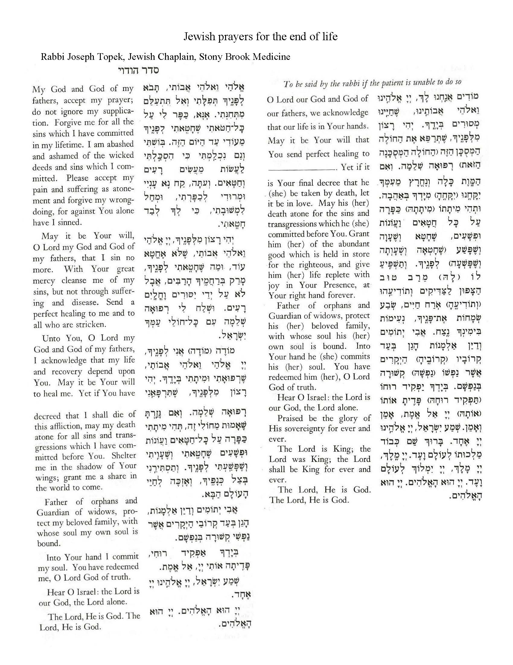

The Islamic (or Muslim) Tradition
Prepared by Khurram Ahmed, M.Div., SBUH Chaplain
Throughout the process, it is important that a Muslim’s modesty – which is often a deeply spiritual practice in life – be maintained even in death. To the best of your ability, please try to keep the patient’s body covered with available linens.

As the patient’s death approaches:
1. The patient's linens should be clean, if possible.
2. Using available means, navigate to YouTube and search for "Qur'an Recitation", and launch one of the thousands of available playlists. The recited Qur'an is always in Arabic, making it something every Muslim - regardless of background - will be familiar with, and hopefully find meaningful. There might be some cultural differences over which passages from the Qur'an are most appropriate at the end of life, but the team should rest assured knowing there is no 'wrong' or 'inappropriate' passage from the Qur'an. Chapter 13 (Surah Ra'd), and Chapter 36 (Surah Yasin) are very common in such times.
3. Family may wish to be 'present' in the room via speakerphone, so they can say relevant prayers. There is a strong belief that a person, if at all possible, die in a state of belief in God by physically affirming their faith through speech. Loved ones will often coach those at the very end of their lives to express and affirm the foundational beliefs of Islam.

In the moments after the patient's death:
1. The deceased's eyes should be gently closed.
2. The deceased's limbs should be straightened, if possible, and the feet brought together.
3. The deceased's head may be wrapped around the chin and over the top, to keep the mouth shut, using available means (like an ACE bandage wrap).
4. The deceased should be completely covered with a clean linen.

Further care:
Muslims aim to bury their deceased as soon as possible, within 24 hours, unless a medical or legal concern demands otherwise. Family will aim to have their funeral home move quickly to secure the release of the deceased. Any support in facilitating and expediting that would be deeply appreciated.

EXCERPTED REFERENCES

International Commission on English in the Liturgy (Ed.) (1983). Pastoral Care of the Sick: Rites of anointing and viaticum. Catholic Book Publishing.
Concordia Publishing House (Ed.), (2007). Pastoral Care Companion. Concordia Publishing.
Royal Science of Self-Realization (Ed.). (1995). The Bhavagad Gita (P. Yogananda, Trans.) Self Realization Fellowship, (c.200 CE).
Harlow, J (Ed.). (1965). Likutei Tefilah: A rabbi’s manual. The Rabbincal Assembly.

