Benjamin J. Luft, MD

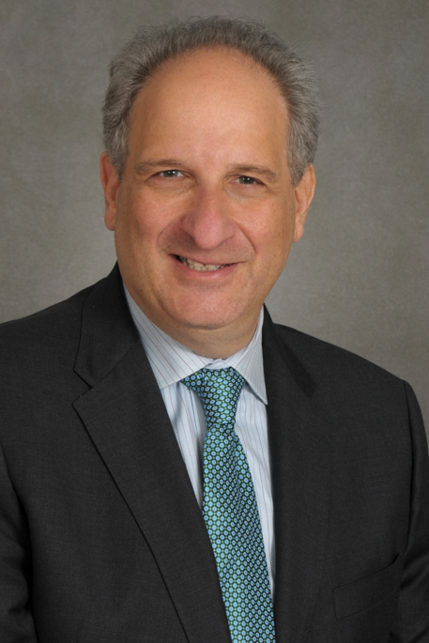
Benjamin J. Luft, MD, is Professor of Medicine and Director and Principal Investigator of the Stony Brook World Trade Center Health and Wellness Program. For more than two decades, he has led one of the nation’s largest programs dedicated to the care and study of World Trade Center responders and survivors. Since 2003, he has overseen the longitudinal follow-up of more than 16,000 responders and survivors, advancing our understanding of the long-term physical, psychological, and neurological consequences of the September 11 attacks.

Under his leadership, the program has established one of the world’s most comprehensive biobanks dedicated to disaster-related illness, containing more than 500,000 biological specimens. This unique resource has supported groundbreaking research into the long-term effects of environmental exposures and psychological trauma, including accelerated aging, chronic disease, cognitive impairment, and post-traumatic stress disorder.

Dr. Luft founded Remembering 9/11: An Oral History of World Trade Center Responders, an initiative now housed in the Library of Congress that preserves the firsthand experiences of those who participated in the rescue, recovery, and cleanup efforts. Through this work, he has sought to ensure that the voices and sacrifices of responders remain part of the nation’s historical record.

An internationally recognized physician-scientist, Dr. Luft has received continuous federal research funding for more than 30 years and has authored more than 200 scientific publications on the health consequences of 9/11, in addition to an extensive body of work in infectious diseases, environmental medicine, and molecular biology. He has served as a consultant to the National Institutes of Health, Centers for Disease Control and Prevention, U.S. Food and Drug Administration, Department of Defense, Infectious Diseases Society of America, and the National Academy of Medicine.

Throughout his career, Dr. Luft has combined compassionate patient care with scientific discovery, working to improve the lives of those affected by environmental disasters and infectious diseases while advancing knowledge that informs patient care and public health.

About the Stony Brook Program

Dr. Luft began laying the foundation for a dedicated health center on Long Island that would be a place where responders could receive specialized care for the unique health challenges they faced. Partnering with Stony Brook University’s Occupational Medicine Clinic, the Stony Brook World Trade Center Clinic (hereafter referred to as “Center”) opened its doors in early 2002 in Port Jefferson, offering free medical screenings to those who had selflessly served at Ground Zero.

Funded through the Zadroga Act since 2011, our program serves a growing number of patients (currently over 16,000) across two clinical sites—Commack and Westbury—covering Nassau and Suffolk counties and extending into the NYC metropolitan area and beyond. Central to our model is the annual medical monitoring exam, designed to document long-term health conditions related to 9/11 exposures. Our clinicians play a critical role in certifying 9/11-related conditions for the federal World Trade Center Health Program. Treatment for 9/11-related conditions is delivered through compassionate, evidence-based care tailored to each patient’s unique needs. Our clinicians are experts in the emerging field of 9/11 medicine, prioritizing ongoing monitoring and specialized interventions to improve quality of life for responders.

Quick Facts
The Stony Brook WTC Health and Wellness Program integrates research and clinical practice to create a medical home for the community of 9/11 responders based on Long Island.
  - 16,000 - WTC responders served as the Long Clinical Center of Excellence for the WTC Health Program (federal program)
  - >200 - peer-reviewed scientific paper published
  - Over $45M, in research awards from NIH and NIA
  - 500,000 samples bio banked for ongoing and future studies
  - 500 personal testimonies archived at the Library of Congress

Key Research
Our Research Program is the driving force to innovation, enhancing our clinical services. A dedicated community of researchers worked to understand the complex health challenges faced by 9/11 responders. Their studies have examined the intricate connections between environmental and psychological exposures at Ground Zero, biological changes, and long-term health outcomes.

Breakthroughs include identifying biomarkers that predict disease progression, uncovering links between toxic exposure and systemic inflammation, recognizing mental health as a driver of outcomes (e.g., disability and healthcare cost), and targeted treatment strategies. These findings not only improve care for responders but also contribute to global knowledge about environmental health and disaster medicine. Today, our Center remains at the forefront of this work, collaborating with national and international experts to ensure that science continues to inform and enhance patient care.

Key peer-reviewed published papers:

Press releases

Faster Aging, Chronic Disease Linked to WTC Responders With PTSD
https://news.stonybrook.edu/newsroom/press-release/medical/faster-aging-chronic-disease-linked-to-wtc-responders-with-ptsd/

Imaging Study Reveals Brain Changes in WTC Responders with Chronic PTSD
https://news.stonybrook.edu/newsroom/press-release/medical/imaging-study-reveals-brain-changes-in-wtc-responders-with-chronic-ptsd/

Study Reveals a Link Between WTC Toxic Exposures and Lung Cancer
https://news.stonybrook.edu/newsroom/press-release/medical/study-reveals-a-link-between-wtc-toxic-exposures-and-lung-cancer/

Long-Term PTSD Symptoms in WTC Responders Bear Watching
https://news.stonybrook.edu/newsroom/press-release/medical/long-term-ptsd-symptoms-in-wtc-responders-bear-watching/

Study Provides Evidence of Amyloidosis in the Brains of Some WTC Responders https://news.stonybrook.edu/newsroom/press-release/medical/study-provides-evidence-of-amyloidosis-in-the-brains-of-some-wtc-responders/

Other Historic Projects
Remembering 9/11 — Oral History Project: This initiative gives responders and their families a much-needed voice, while offering our local and national communities a deeper understanding of the continuing impact of 9/11.
https://www.loc.gov/collections/benjamin-luft-collection-of-9-11-oral-histories

We’re Not Leaving: First published in 2011, We’re Not Leaving chronicles the harrowing day of 9/11, the rescue and recovery that followed, and the enduring social, physical, and psychological toll on those who answered the call.
https://a.co/d/02dt6VzU

9/11: An American Requiem: This documentary film tells the story of 9/11 and the days that followed through the perspective of the 9/11 responders. Debuting at the Stony Brook Film Festival and featured on 60 Minutes, this powerful documentary continues to provide a unique look at the impact of the 9/11 disaster.
https://youtu.be/28DZUUAOx68?si=jYJUYMwqWSFS8eIk

Teaching 9/11: A comprehensive unit for high school students: Our curriculum contains lesson plans based on the first-hand experiences of the people who responded to the 9/11 disaster. It was developed to foster critical thinking, conscious reflection, and active learning experiences.
https://sharemylesson.com/teaching-resource/teaching-911-comprehensive-unit-high-school-students-277585

Media Contact
Greg Filiano
Media Relations Manager, Stony Brook Medicine
Office of Communications and Marketing
Stony Brook University
Facebook | Twitter
Office: 631.444.9343
Cell: 631.338.7644
gregory.filiano@stonybrookmedicine.edu

