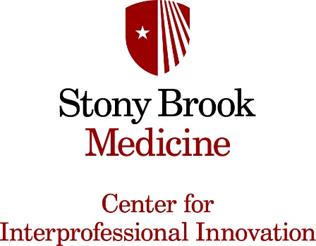
Interprofessional Education Course
Summer 2026

Virtual Interprofessional Team Learning and Simulation

Course Description: Join students from the School of Medicine, Nursing, Social Welfare, Dental, and Health Professionals in a 4 week intensive virtual class that will focus on developing and strengthening core interprofessional competencies – teamwork, communication, values and ethics and roles and responsibilities.

Classes will consist of didactic information, team-building activities, interactive discussions, and two opportunities for interprofessional teams to work with standardized patients via telehealth. Students will complete asynchronous course modules in preparation for each week’s synchronous classes. Other team based activities may also be assigned.

Credit: Course, service and/or practicum credit for completion of the course is based on individual program requirements.

Location: Synchronous Zoom classes
When: June 2 – 25, every Tuesday & Thursday 5 – 7 pm
Facilitators: Dr. Kelli Star Fox, Dr. Jeanette Lukas, Dr. Bonnie Lipow, Prof. Erik Flynn, Dr. Gabriella Pandolfelli, Prof. Kathleen McGoldrick.

Please contact Kelli Star Fox@ stonybrookmedicine.edu for more information. To register for this course please complete the online form: https://forms.gle/oydsVtPCPrHAvfE99

Participants will earn the Excellent in Interprofessional Collaboration
digital badge upon meeting all course requirements.
