Instructions for entering the “Community Physician Portal”
** If you have a NEW account, ensure that you have received your Access e-mail from the Physician Outreach Office and have accepted your accounts via the link in that e-mail, prior to logging into the Portal Site***

Make note of your Username and Password and save it in a secure place.
Please note, once you have accepted your account, we are unable to help you with your username and password. For User Name and Password assistance for existing accounts, contact the HELP Desk at 631-444-HELP (4357)**

Important Contact Phone Numbers

Connecting to your Patients not showing in your Practice Group:
631-638-INFO (4636) or you may email the Physician Outreach group:
Ashley.Miller@stonybrookmedicine.edu
Kayla.Cohen2@stonybrookmedicine.edu
Susan.Bronson@stonybrookmedicine.edu

User Name and Password Assistance (Cerner):
HELP Desk 631-444-HELP (4357)

Applications, Instructions and On-Site Training:
631-638-4636

To log in to the Community Physician Portal, go to:
www.stonybrookmedicine.edu/CommunityPhysicianPortal
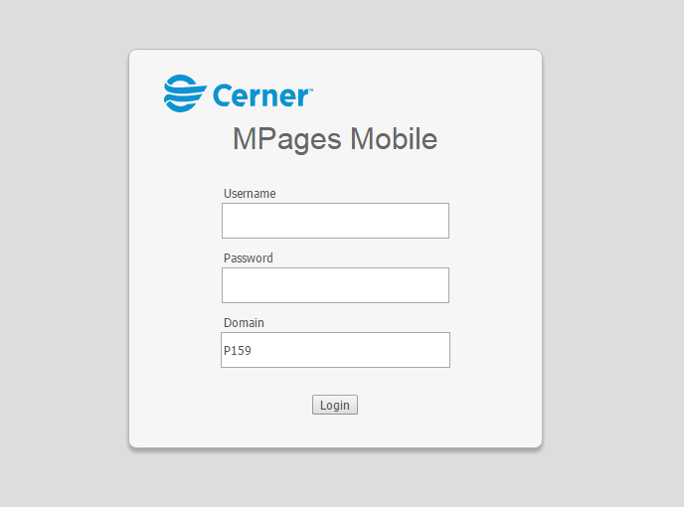
PLEASE NOTE: You MUST use Google Chrome, Firefox or Internet Explorer 10 or higher.
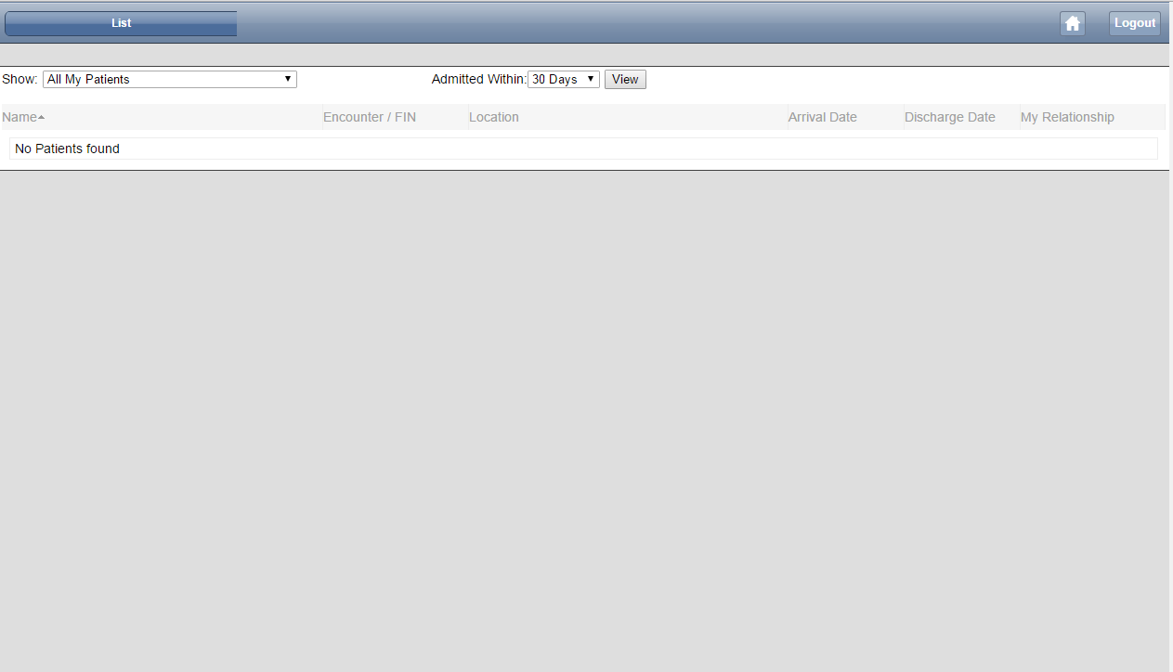
You are now in the Community Physician Portal and can look up your patient’s record. Click on the first drop down that says “Show” and select your practice name. A second drop down will then appear. You can either use the entire provider list, or click on a provider’s name to get the related patients within your practice. Limiting the “Admitted Within” time helps to speed up load time on those whom you are trying to locate records on. Select view.
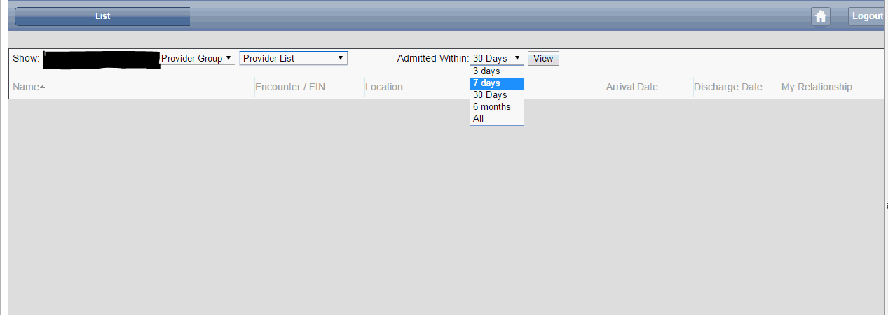
Your patient list will populate and you can find the record you are looking for. There is no search feature but you can use “Ctrl F” and a box will pop up where you can enter the patients name to find them on your populated list.
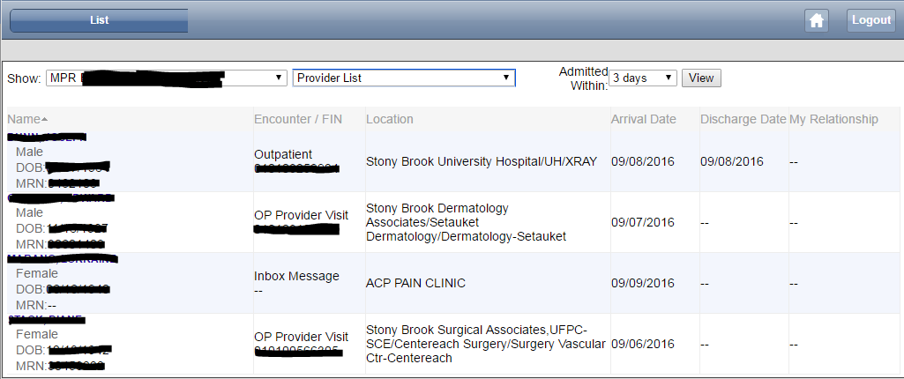
Click on the desired patient record you would like to view. The patient’s name, DOB, sex and Encounter number will appear at the top in the blue bar and the information is easily laid out on the page for you to find.

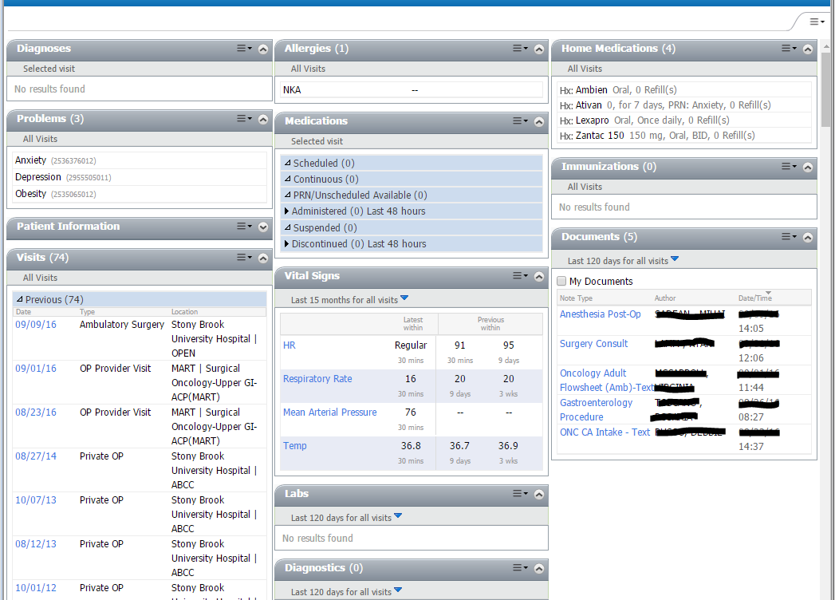

Once you are in the patients chart you will have access to everything they have had done at Stony Brook Hospital or any of our outpatient practices. The only current limitation is images. You may read a radiology report, but you can’t view the image. All information from the past five years is available to you. Below is a short description of what you will find in each section.

Diagnoses- Any major diagnoses that the patient has reported, or we have diagnosed them with. This is a read only section, you can’t print anything from here.

Problems- Similar to diagnoses. This is a read only section, you can’t print anything from here.

Patient Information – Basic demographics, chief complaints, emergency contact information. This is a read only section, you can’t print.

Visits- In this section you will be able to see every previous and future appointment. You can click on any of the appointments to view their insurance information. Visit details and results are not available in this section.

Allergies – Medication or environmental allergies will be listed here.

Medications – If the patient was inpatient with us this section will list any medications they were given.

Vital Signs- Heart rate and temperature. You can click on each to view recent results, but you won’t be able to print from this section.

Labs – Any bloodwork we have done on the patient. You can click the blue arrow to expand the timeframe of results. You can click on each lab to expand and view results. You cannot print from this section. I have attached separate instructions to this email that show you how to run a labs report.

Diagnostics - All diagnostic testing we have done on the patient. You can click the blue arrow to expand the timeframe of results. You can click on any of the reports to view/print.

Pathology - All pathology we have done on the patient. You can click the blue arrow to expand the timeframe of results. You can click on any of the reports to view/print.

Microbiology – Information such as results on cultures done on your patient. You can click on any of the available result. You cannot print from this section.

Home Medications – All medications the patient reports taking at home. You can hover your house over each medication to get more detailed information.

Immunizations – A list of immunizations your patient has received at Stony Brook. This will not include immunizations the patient has reported receiving elsewhere.

Documents – This section will have just about everything you are looking for on your patient. You will find everything from progress notes, provider notes, ambulatory patient summaries and many other very helpful documents. You can click on the blue arrow to expand the time frame. Any of the documents you open up here can be printed.

If a treatment relationship was never designated by the mutual patient, they will not automatically populate into your account. If one of your patients is not showing in your practice group, create a treatment relationship by calling our office at the number below. Please contact us is you have a new patient prior to the appointment or transfer in order to expedite connection.

Important Contact Phone Numbers

Connecting to your Patients:
631-638-INFO (4636)

User Name and Password Assistance (Cerner):
HELP Desk 631-444-HELP (4357)

Applications, Instructions and Training:
631-638-4636

